Sept 16-20 2019 (Mon-Fri clas[s](https://meet.wellsfargo.com/linda.dixson/V2L1HHD9?sl=1))

**Modern Web Development Course (HTML5, CSS3, ES6)**

**Instructor**: Judy Lipinski

To reach THIS document:

<http://moxie.pro/2019sept16hunt>

Getting the course files on the ProTech machine

put this entire command into the C: prompt

git clone <https://github.com/JudyLipinski/modernweb>

[**Links to list of machine assignments**](https://docs.google.com/spreadsheets/d/1MN-AoDxBy7StJ1OA1f5L1fkKdkOGBJfyImpiLlc7HjM/edit#gid=0)

Welcome to Class!

We will introduce the course and then get you connected to your lab machines.

Initial Setup:

* make sure you set your resolution to the recommended setting
  + Right click desktop | Display Settings | Resolution (choose Recommended settings - may need to scroll to top of list to see it)
  + [http://protechtraining4.webex.com](http://protechtraining4.webex.com/)

**Contents:**

Class Setup

Good resources for HTML, CSS and JS

Parking Lot

Music Requests (youtube links)

Tech Discussions

Non-Tech Discussions

Daily Review:

https://www.youtube.com/watch?v=uguXNL93fWg

We will introduce the course and then get you connected to your lab machines. From there you will be able to access this page.

**Electronic Links to Chapters:**

[Chapter 0 Introduction](https://docs.google.com/presentation/d/e/2PACX-1vTqhVjGWzRS1085hLrtmpJpEA_ZB-fV-C9h2re8bIroem8J_PQ-f1wVuNIzdORem60eMH_YhqH-sbUF/pub?start=false&loop=false&delayms=3000)````````````````

[Chapter 1 Overview of Modern Web Dev and Node](https://docs.google.com/presentation/d/e/2PACX-1vTxrbg4nGBFBk5lfsoirSLdaeJjL0Sh_fFLBRkvCjkjw8GQdtTqMsCM7qdRsJlVUnvUwWYHKQlgVDow/pub?start=false&loop=false&delayms=3000)

[Chapter 2 Working with Browsers](https://docs.google.com/presentation/d/e/2PACX-1vRxziBd0cgtFvqnI6W6TEODxuIJ6oFzOcIIaGGmXGjh0x5QJnx3r7_WcCrdok-B4hPVWgqKBZF4euo1/pub?start=false&loop=false&delayms=3000)

[Chapter 3 HTML5 Elements](https://docs.google.com/presentation/d/e/2PACX-1vTIot-OqA5lUtXx_NT8raIw3-i2cDmsl4Qg2dNzRRTKLpcSwX4v1Zo-6lJBUftx2HuTbCX4wonrgTMT/pub?start=false&loop=false&delayms=3000)

[Chapter 4 CSS3 Features](https://docs.google.com/presentation/d/e/2PACX-1vTdG8_4adnQjSqBdAd9N50_sU_ynmUPJCtLW_lz0is-pFp1tCXtey3U1gvclXXOPOoQSFP6SKTbjD3S/pub?start=false&loop=false&delayms=3000)

[Chapter 5 Responsive Web Design & Bootstrap](https://docs.google.com/presentation/d/e/2PACX-1vTi1a_lW04P0lFxV-AJZnhzs5GxP3RBnfB9KKPOJ4jkifoBD6zxwzHkMJ5-rp0r7bwfW7KiQztrOVuF/pub?start=false&loop=false&delayms=3000)

[Chapter 6 Modern JavaScript](https://docs.google.com/presentation/d/e/2PACX-1vSapQXbFJ8rkV34DGdao6UxSCdPWzxWW-ri75TuF0pSczZxpAorqvx0q61KUV3hKA4Z19eiBibS5Rgx/pub?start=false&loop=false&delayms=3000)

[Chapter 7 Client-Side APIs](https://docs.google.com/presentation/d/e/2PACX-1vSxFjqiqMX_QfsmLeW53-mKIw2MSZdTmf5MxntyBiXioYHpR3grgwNID0CB5Oh7-VoHVgEoSJqRGQmD/pub?start=false&loop=false&delayms=3000)

[Chapter 8 Working with HTML5 Forms](https://docs.google.com/presentation/d/e/2PACX-1vSdkkxSDb30bRh80ULAwf4EM8Vbe44JRSsAhycSzYz0DpylTdjNGbj3BB3A8OyfCwBbTbNtBaHneAj_/pub?start=false&loop=false&delayms=3000)

[Chapter 9 JavaScript Modules](https://docs.google.com/presentation/d/e/2PACX-1vRtKpwnZf4fE0ifnoLSfVZTio_46kOCw8gc_HzIgZrdI_SSPRjZdRyjCVAGNC0nMG_d_lBhm4cKZAMj/pub?start=false&loop=false&delayms=3000)

[Chapter 10 Unit Testing JavaScript](https://docs.google.com/presentation/d/e/2PACX-1vTENWCNE3cuAREbIKe5BArsHX0syh8HOxG6dMwE4SOKBEQCJN5zdGEaAUJwByl0hQVK53jXRbuKuCDC/pub?start=false&loop=false&delayms=3000)

[Chapter 11 Summary](https://docs.google.com/presentation/d/e/2PACX-1vQBrS9DN3Qr5F_-rTNKGo6ztB3JQGtZbLfK79Q-mlSqEpyFL6pT7fBi0FqC3V82kFxeyzbr-wOUGmXT/pub?start=false&loop=false&delayms=3000)

# Class Setup

**Connecting to the ProTech Training Virtual Machines**

1. [**Link to Protech VM connection presentation**](https://docs.google.com/presentation/d/1djTRHnVS0Etjrq6ScR3RRsVvOQPW-R1CUwi6YkgpCII/edit?usp=sharing)

**Use Control + Alt + shift to bring up the side menu**

**Its a toggle, do it again to close the window**

**Good for copy/paste between your host & virtual machine**

Please use spreadsheet to check in:  
 [**Links to list of machine assignments**](https://docs.google.com/spreadsheets/d/1MN-AoDxBy7StJ1OA1f5L1fkKdkOGBJfyImpiLlc7HjM/edit#gid=0)

[Student Computer Assignments: 2019 09 16 Modern web Judy](https://docs.google.com/spreadsheets/d/1MN-AoDxBy7StJ1OA1f5L1fkKdkOGBJfyImpiLlc7HjM/edit#gid=0)

Pa$$w0rd (zero no o)

# Good resources for HTML, CSS and JS

* W3chools: <http://w3schools.com>
* MDN - mozilla developer network <https://developer.mozilla.org/en-US/docs/Web>

# Parking Lot

* Add any items here to discuss if there is time before class ends
* Part 3, 1, e - “the” is misspelled THANK YOU!!! :)

# Music Requests (youtube links)

* a

# Tech Discussions

* Microsoft buys GitHub <https://news.microsoft.com/2018/06/04/microsoft-to-acquire-github-for-7-5-billion/>
* Screen capture tools help communicate more
  + <https://app.prntscr.com/en/index.html> LightShot
* With devtools open you can prevent caching
  + 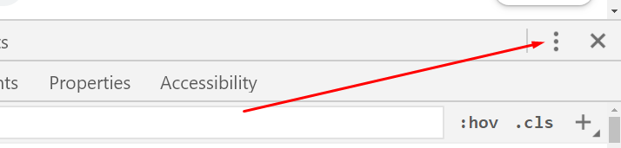
  + 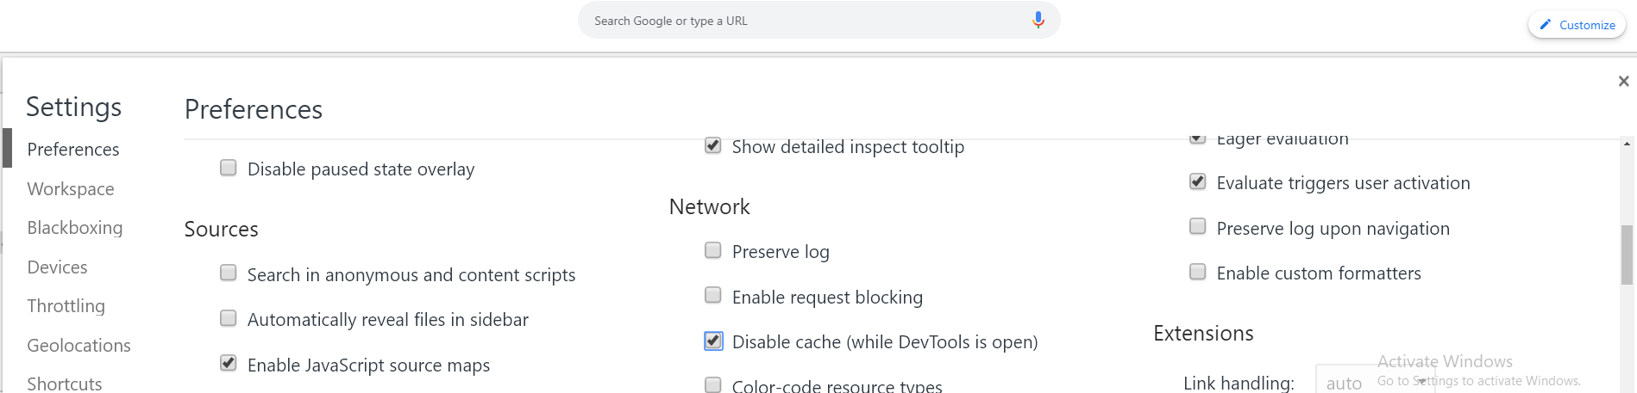
* 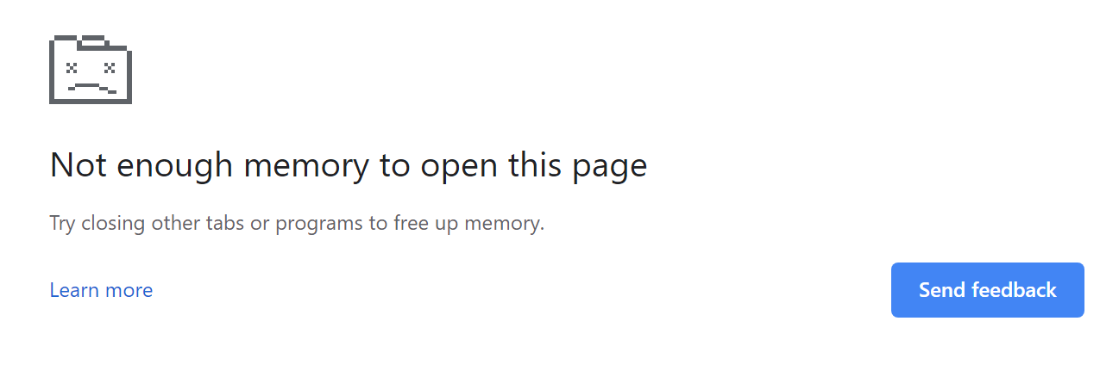
* <https://angular.io/guide/browser-support>
* <http://pauljadam.com/demos/css-line-through-del-ins-accessibility.html>
  + Any other references?
* Browser events
  + <https://developer.mozilla.org/en-US/docs/Web/Events>
* <http://html5doctor.com/downloads/h5d-sectioning-flowchart.png>
* Sans-serif: H F T G P L
* Serif: H F T G P L
* Study Array.prototype
  + <https://developer.mozilla.org/en-US/docs/Web/JavaScript/Reference/Global_Objects/Array/prototype>
* CircuitPy

# CircuitPython demo - NeoPixel

import time

import board

import neopixel

print("Starting.")

pixel_pin = board.D5

num_pixels = 30

pixels = neopixel.NeoPixel(pixel_pin, num_pixels, brightness=0.3, auto_write=False)

def wheel(pos):

# Input a value 0 to 255 to get a color value.

# The colours are a transition r - g - b - back to r.

if pos < 0 or pos > 255:

return (0, 0, 0)

if pos < 85:

return (255 - pos * 3, pos * 3, 0)

if pos < 170:

pos -= 85

return (0, 255 - pos * 3, pos * 3)

pos -= 170

return (pos * 3, 0, 255 - pos * 3)

def color_chase(color, wait):

for i in range(num_pixels):

pixels[i] = color

time.sleep(wait)

pixels.show()

time.sleep(0.5)

def color_odds(color, wait):

for i in range(num_pixels):

if i%2==0:

continue;

pixels[i] = color

time.sleep(wait)

pixels.show()

time.sleep(0.5)

def color_evens(color, wait):

for i in range(num_pixels):

if i%2!=0:

continue;

pixels[i] = color

time.sleep(wait)

pixels.show()

time.sleep(0.5)

def rainbow_cycle(wait):

for j in range(255):

for i in range(num_pixels):

rc_index = (i * 256 // num_pixels) + j

pixels[i] = wheel(rc_index & 255)

pixels.show()

time.sleep(wait)

RED = (255, 0, 0)

YELLOW = (255, 150, 0)

GREEN = (0, 255, 0)

CYAN = (0, 255, 255)

BLUE = (0, 0, 255)

PURPLE = (180, 0, 255)

while True:

print("Cycling.")

# pixels.fill(RED)

# pixels.show()

# # Increase or decrease to change the speed of the solid color change.

# time.sleep(1)

# pixels.fill(GREEN)

# pixels.show()

# time.sleep(1)

# pixels.fill(BLUE)

# pixels.show()

# time.sleep(1)

# color_chase(RED, 0.1) # Increase the number to slow down the color chase

# color_chase(YELLOW, 0.1)

# color_chase(GREEN, 0.1)

# color_chase(CYAN, 0.1)

# color_chase(BLUE, 0.1)

# color_chase(PURPLE, 0.1)

# color_odds(RED,0.1)

# color_evens(BLUE,0.1)

# color_odds(PURPLE,0.1)

# color_evens(YELLOW,0.1)

# color_odds(GREEN,0.1)

# color_evens(CYAN,0.1)

rainbow_cycle(0) # Increase the number to slow down the rainbow

* Static, Relative, Absolute, Fixed: CSS Positioning Explained
  + <http://nigelbuckner.com/downloads/handouts/web/pos-explained/index.html>
* Private fields (proposal is one stage away from completion)
  + <https://github.com/tc39/proposal-class-fields#private-fields>
  + [Already added to latest Chrome version](https://blog.chromium.org/2019/03/chrome-74-beta-reducing-unwanted-motion.html)
  + [Babel example using the proposal](https://babeljs.io/repl#?babili=false&browsers=&build=&builtIns=false&spec=false&loose=false&code_lz=MYGwhgzhAEAKCmAnCB7AdtA3gKGtAxGAObzQC80AjAJwDc2uBAlmsIvJPAIIkAUAlFkZ4ALgAsmEAHSESAajn08AXwZ4SInvAFC8ediICuiDOMkzi2_kuirV2YOggjoAB3LQ08AO5wkqNAF6RzRUEHgpEBQiXlcpDS0BayA&debug=false&forceAllTransforms=false&shippedProposals=false&circleciRepo=&evaluate=false&fileSize=false&timeTravel=false&sourceType=module&lineWrap=true&presets=es2015%2Cstage-3&prettier=false&targets=&version=7.6.0&externalPlugins=)
* All current ECMAScript proposals
  + [https://github.com/tc39/proposals](https://github.com/tc39/proposals#ecmascript-proposals)

# Non-Tech Discussions

* Get $12 towards your first order from GrubHub
  + <https://www.grubhub.com/referral/efb6c10e-487e-11e4-9697-9cb654858910>
* Get a Carbon Monoxide Detector
* Get you yearly medical checkups and do your self examinations!
* <http://npic.orst.edu/factsheets/PermGen.html>
* Parrot - let the bodies hit the floor <https://www.youtube.com/watch?v=uguXNL93fWg>
* Groff & Groff Wood <https://www.groffslumber.com/>
  + Rosewood

# Daily Review:

What was something new or helpful for you yesterday?

Do you have any questions?

Fri am

* Dewaxed shellac on an oily wood
* Constructor Functions
  + function CapitalizedNameByConvention()
  + Use it by calling with x = new CapitalizedNameByConvention()
  + Inside of the function
    - To set properties, use the keyword this

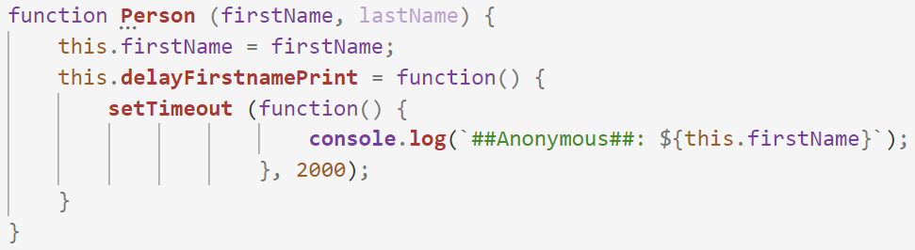

* In memory the arguments of a function are in an array, that is part of a property for the function object
* Using const abc = { name: ‘Bob’}
  + Is this legal? abc.name = ‘Jerry’ YES
  + Is this legal? abc = {email: ‘[a@a.com](mailto:a@a.com)’} NO
* Bootstrap
  + Learning different classes
  + Include bootstrap, then use classes for different effects

Thurs am

* Link with positioning (under tech discussion)
* Descendant Selectors (use space)
  + nav li { dsiplay: inline}
* New CSS3 selectors
  + + h1 + h2
    - /* targets h2 that IMMEDIATELY follows no siblings between*/
  + ~ h1 ~ h2
    - Targets h2 - but can have siblings between
  + > ul > li
    - Targets li where it is an IMMEDIATE child of ul
    - <ul>
      * <li>
        + <ol>

<li></li>

* Attribute Selectors
  + End with a[href$=”.pdf”]
  + Starts with a[href^=”#”]
  + Exact match a[title=”todo”]
  + Exact match a[title*=”the”]
* Now in VSCode hover over html elements to get links to MDN
* Hover of CSS selectors to see which HTML it will target
* New color
  + rgb()
  + Hsl, hsla <http://hslpicker.com/#269dd9>
* Link styling order is important: **L**o**V**e **HA**te
  + A:link {} a:visited{} a:hover{} a:active{}
* VSCode formatting Shift + Alt + F

Wed am

* Modernizr for feature detection
* Semantic Tags
  + Article
* Use of dev tools for debugging
* Emmet Abbreviations <https://en.wikipedia.org/wiki/Emmet_(software)>
* HTMLTagWrap
* HTMLHint

Tues am

* Windows
  + Opening a prompt from Windows Explorer
* JSON
  + syntax
* Node
  + Running JS outside of browser
  + Running a Node server
* VSCode
  + Left and right arrow to expand and collapse folder structures
  + **Terminal** - can be opened to execute node
    - Shortcut is control + `
    - Can choose between terminal shell types

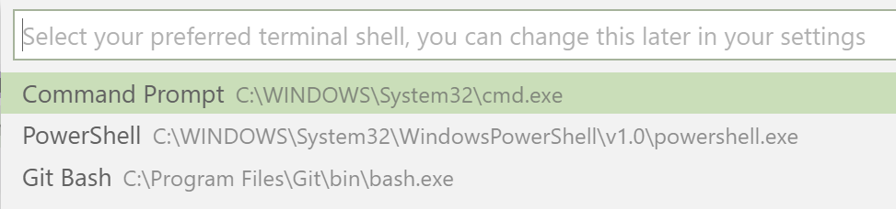

From the dropdown in terminal, or control shift p - terminal shell

* + Can do source control inside of VSCode
* Mark down (since 2004)
  + Used by Bitbucket and GitHub to display project info
* Json-server
  + Mocks a back end rest API
  + Helpful when trying to do front-end and back end is no developed yet